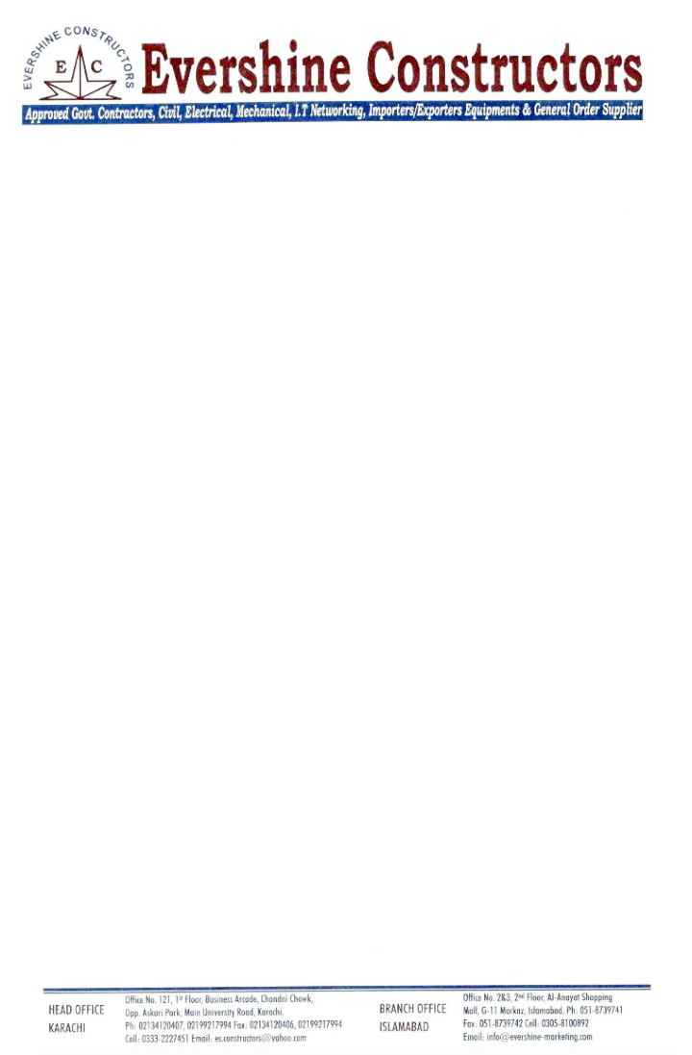

Ref No: ESC/RSNS/C/35/ Date: <To>

**TO WHOM IT MAY CONCERN**

This is to certify that Mr. <Name> S/o <fname> CNIC #: <CNIC> has worked with us in our organization as <Designation> from <From> to <To> at Demolition & Reconstruction of Railway Station at Sahiwal. We found his work satisfactory. He was hard working and keen in his work. He always worked for the best of our organization. We wish his the best in his career and would like to thank him for his excellent contribution.

Thanking you,

**Yours Faithfully,**



**For M/S Ever Shine Constructors.**

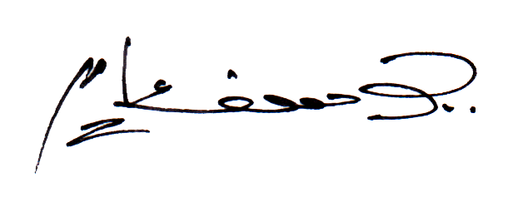

**Engr. Yousaf Aamir**

**Project Manager**